Practical 1
TASK1: Develop a C program that demonstrates how a Linux operating system executes a command entered by a user.Accept a Linux command as input. Create a child process using fork(). Execute the command in the child process using an appropriate exec() system call. Allow the parent process to wait for the child using wait(). Display the Process ID (PID) of both the parent and child processes.
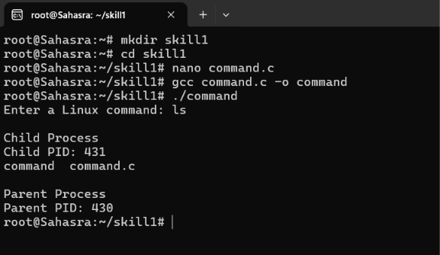

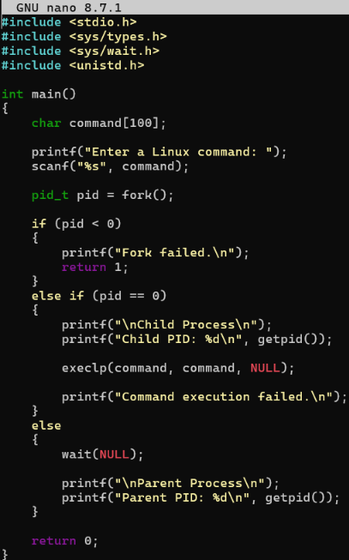

TASK2: Using Linux terminal commands (uname, lscpu, lsblk, ps, top), investigate the relationship between hardware resources and operating system services.Prepare a report explaining how the operating system abstracts the following resources:CPU ,Memory ,Storage and Input/Output (I/O) devices
